Comp Sci 1: VB Express
Midterm Project

Trouble

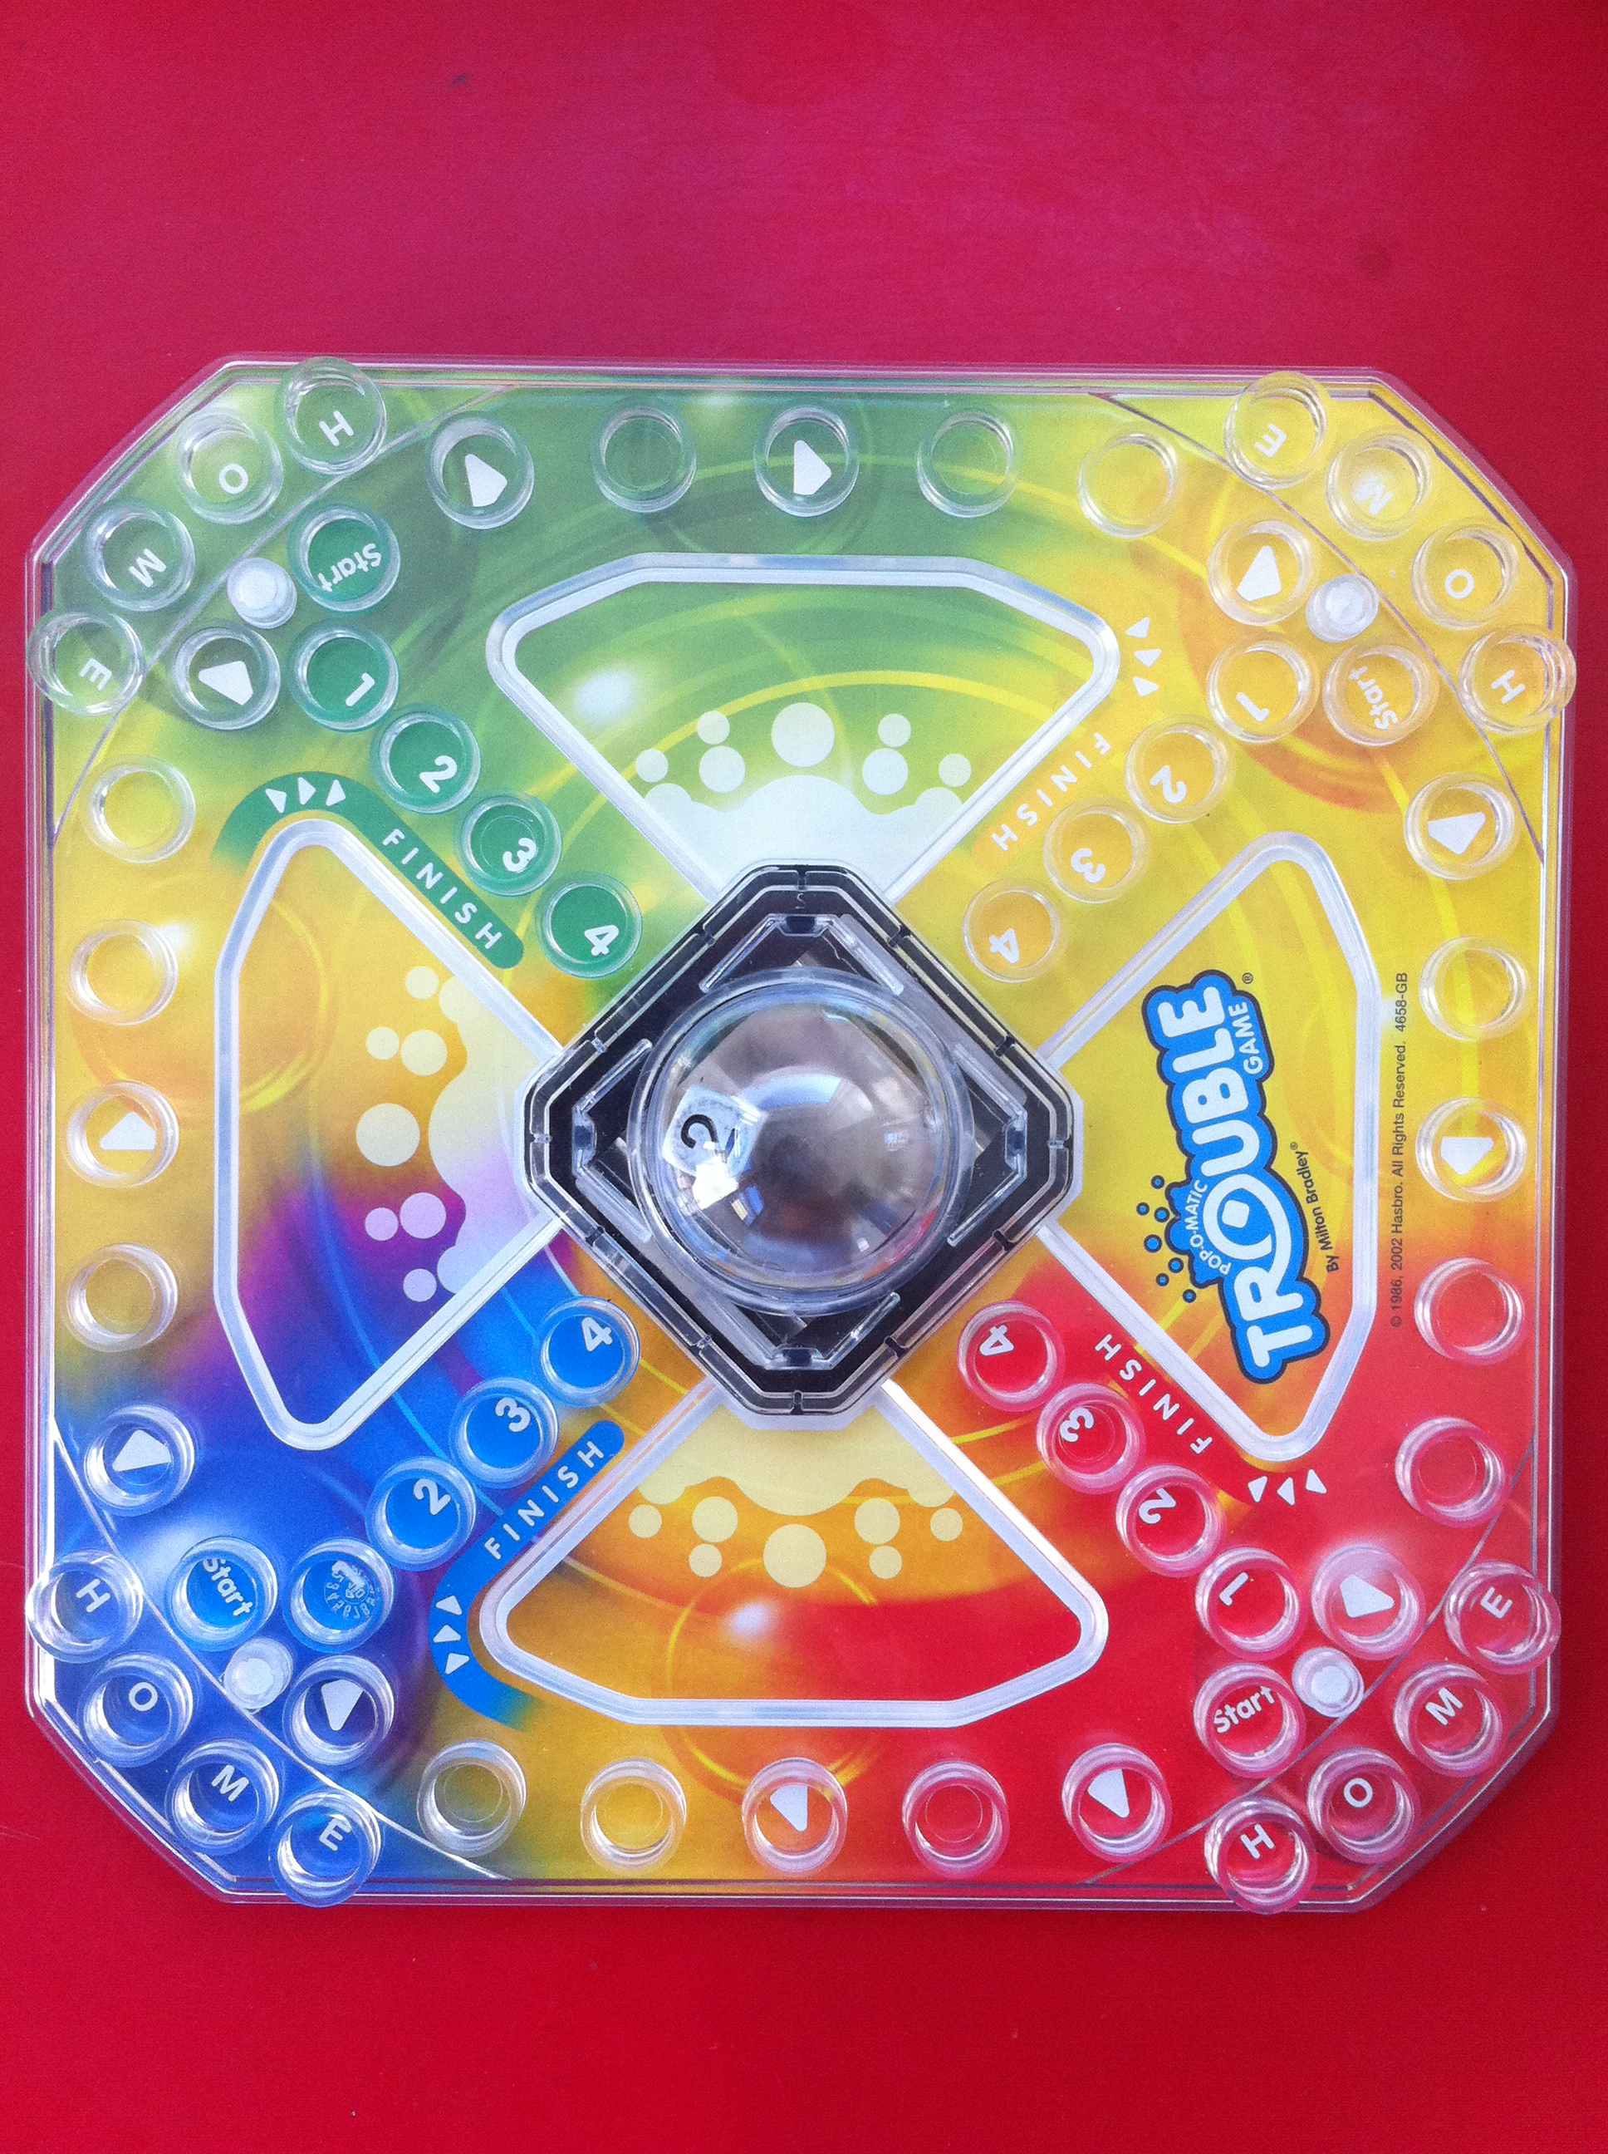

You are to design a game called “Trouble” that allows up to FOUR players to compete against each other.

The GAME consists of a series of 28 positions, grouped as 4 sets of 7 positions (one for each PLAYER/COLOR. The grid can consist of a series of buttons, Textboxes or any other object with which you want to work.

In addition, there are 4 HOME positions plus 4 FINISH positions for EACH player.

AT THE START OF THE GAME, the HOME positions are filled for each player.

A “Coin toss” decides who goes first.

Players alternately "PRESS" the dice bubble. A player needs a 6 to "START" a new peg.
Ensuing turns either start a new peg or move an existing peg around the board. A peg is "SAFE" when it enters the FINISH area.

The first player to move all their pegs to the FINISH area, wins.

If a player's peg lands ON another players peg, that peg must return HOME.

GRADING:

A Level Fulfill ALL of the requirements listed plus provide a clean GUI

A- / B+ Fulfill ALL of the requirements listed, Poorly designed GUI

B / B- Fulfill ALL of the requirements listed, However poorly designed algorithms or iterations

C / C- Not all of the elements completed plus excessive Help from Teacher or
others

